# Lab: Classes

Problems for exercises and homework for the [“JavaScript Advanced” course @ SoftUni](https://softuni.bg/trainings/2081/js-advanced-october-2018). Submit your solutions in the SoftUni judge system at <https://judge.softuni.bg/Contests/1533>.

# Classes

## Rectangle

Write a JS **class** for a rectangle object. It needs to have a **width** (Number), **height** (Number) and **color** (String) properties, which are set from the constructor and a calcArea() method, that calculates and **returns** the rectangle’s area.

### Input

The constructor function will receive valid parameters.

### Output

The calcArea() method should **return** a number.

Submit the class definition as is, **without** wrapping it in any function.

### Examples

|  |  |
| --- | --- |
| Sample Input | Output |
| let rect = new Rectangle(4, 5, 'red');  console.log(rect.width);  console.log(rect.height);  console.log(rect.color);  console.log(rect.calcArea()); | 4  5  Red  20 |

## Person

Write a JS **class** that represents a personal record. It has the following properties, all set from the constructor:

* firstName
* lastName
* age
* email

And a method toString(), which prints a summary of the information. See the example for formatting details.

### Input

The constructor function will receive valid parameters.

### Output

The toString()method should **return** a string.

Submit the class definition as is, **without** wrapping it in any function.

### Examples

|  |
| --- |
| Sample Input |
| let person = new Person('Maria', 'Petrova', 22, 'mp@yahoo.com');  console.log(person.toString()); |
| Output |
| Maria Petrova (age: 22, email: mp@yahoo.com) |

## Get Persons

Write a JS function that returns an array of Person objects. Use the class from the previous task, create the following instances, and return them in an array:

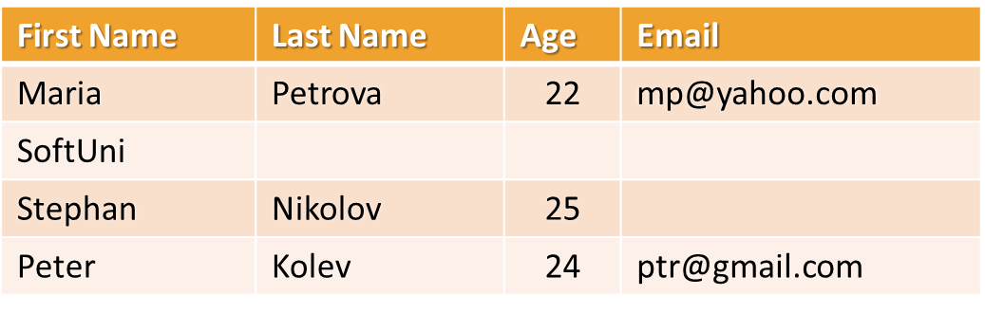

For any empty cells, do not supply a parameter (call the constructor with less parameters).

### Input / Output

There will be **no input**, the data is static and matches the table above. As **output**, **return an array** with Person **instances**.

Submit a function that returns the required output.

## Circle

Write a JS **class** that represents a **Circle**. It has only one data property – it’s **radius**, and it is set trough the **constructor**. The class needs to have **getter** and **setter** methods for its **diameter** – the setter needs to calculate the radius and change it and the getter needs to use the radius to calculate the diameter and return it.

The circle also has a getter area(), which calculates and **returns** its area.

### Input

The constructor function and diameter setter will receive valid parameters.

### Output

The diameter() and area() getters should **return** numbers.

Submit the class definition as is, **without** wrapping it in any function.

### Examples

|  |  |
| --- | --- |
| Sample Input | Output |
| let c = new Circle(2);  console.log(`Radius: ${c.radius}`);  console.log(`Diameter: ${c.diameter}`);  console.log(`Area: ${c.area}`);  c.diameter = 1.6;  console.log(`Radius: ${c.radius}`);  console.log(`Diameter: ${c.diameter}`);  console.log(`Area: ${c.area}`); | 2  4  12.566370614359172  0.8  1.6  2.0106192982974678 |

## Point Distance

Write a JS **class** that represents a **Point**. It has **x** and **y** coordinates as properties, that are set through the constructor, and a **static method** for finding the distance between two points, called distance().

### Input

The distance() method should receive two **Point** objects as parameters.

### Output

The distance() method should **return** a number, the distance between the two point parameters.

Submit the class definition as is, **without** wrapping it in any function.

### Examples

|  |  |
| --- | --- |
| Sample Input | Output |
| let p1 = new Point(5, 5);  let p2 = new Point(9, 8);  console.log(Point.distance(p1, p2)); | 5 |

## Cards

You need to write an **IIFE** that results in an object containing two properties Card which is a class and Suits which is an object that will hold the possible suits for the cards.

The Suits object should have exactly these 4 properties:

* **SPADES**: ♠
* **HEARTS**: ♥
* **DIAMONDS**: ♦
* **CLUBS**: ♣

Where the key is **SPADES**, **HEARTS** e.t.c. and the value is the actual symbol ♠, ♥ and so on.

The Card class should allow for creating cards, each card has 2 properties **face** and **suit**. The **valid** faces are the following ["2", "3", "4", "5", "6", "7", "8", "9", "10", "J", "Q", "K", "A"] any other are considered invalid.

The Card class should have setters and getters for the **face** and **suit** properties, when creating a card or setting a property validations should be performed, if an invalid face or a suit not in the Suits object is passed an Error should be **thrown**.

### Code Template

You are required to write and submit an **IIFE** which results in an object containing the above-mentioned Card and Suits as properties. Here is an example template you can use:

|  |
| --- |
| cards.js |
| (**function**(){  *//* ***TODO***  **return** {  **Suits**:***Suits***,  **Card**:***Card*** } }()) |

### Screenshot

An example usage should look like this:

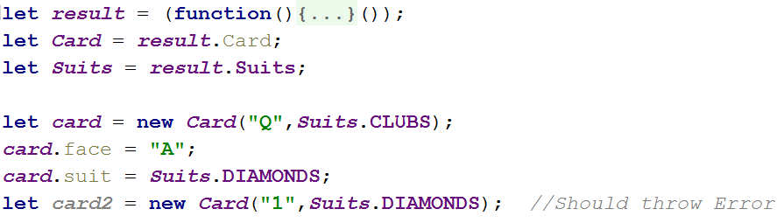

# Unit testing on Classes

## String Builder

You are given the following **JavaScript class**:

|  |
| --- |
| string-builder.js |
| **class** StringBuilder {  constructor(string) {  **if** (string !== ***undefined***) {  StringBuilder.*_vrfyParam*(string);  **this**.**_stringArray** = Array.from(string);  } **else** {  **this**.**_stringArray** = [];  }  }   append(string) {  StringBuilder.*_vrfyParam*(string);  **for**(**let** i = 0; i < string.**length**; i++) {  **this**.**_stringArray**.push(string[i]);  }  }   prepend(string) {  StringBuilder.*_vrfyParam*(string);  **for**(**let** i = string.**length** - 1; i >= 0; i--) {  **this**.**_stringArray**.unshift(string[i]);  }  }   insertAt(string, startIndex) {  StringBuilder.*_vrfyParam*(string);  **this**.**_stringArray**.splice(startIndex, 0, ...string);  }   remove(startIndex, length) {  **this**.**_stringArray**.splice(startIndex, length);  }   **static** *_vrfyParam*(param) {  **if** (**typeof** param !== **'string'**) **throw new TypeError**(**'Argument must be string'**);  }   toString() {  **return this**.**_stringArray**.join(**''**);  } } |

### Functionality

The above code defines a **class** that holds **characters** (strings with length 1) in an array. An **instance** of the class should support the following operations:

* Can be **instantiated** with a passed in **string** argument or **without** anything
* Functionappend(string) – **converts** the passed in **string** argument to an **array** and adds it to the **end** of the storage
* Function **prepend**(**string**) – **converts** the passed in **string** argument to an **array** and adds it to the **beginning** of the storage
* FunctioninsertAt(string, index) – **converts** the passed in **string** argument to an **array** and adds it at the **given** index (there is **no** need to check if the index is in range)
* Functionremove(startIndex, length) – **removes** elements from the storage, starting at the given index (**inclusive**), **length** number of characters (there is **no** need to check if the index is in range)
* FunctiontoString() – **returns** a string with **all** elements joined by an **empty** string
* All passed in **arguments** should be **strings.** If any of them are **not**, **throws** a type **error** with the following message: "**Argument must be a string**"

### Examples

This is an example how this code is **intended to be used**:

|  |  |  |
| --- | --- | --- |
| Sample code usage |  | Corresponding output |
| **let** str = **new** StringBuilder(**'hello'**); str.append(**', there'**); str.prepend(**'User, '**); str.insertAt(**'woop'**,5 ); **console**.log(str.toString()); str.remove(6, 3); **console**.log(str.toString()); | User,woop hello, there  User,w hello, there |

### Your Task

Using **Mocha** and **Chai** write **JS unit tests** to test the entire functionality of the StringBuilder class. Make sure it is **correctly defined as a class** and instances of it have all the required functionality. You may use the following code as a template:

|  |
| --- |
| describe(**"*TODO* …"**, **function**() {  ***it***(**"*TODO …*"**, **function**() {  *//* ***TODO:*** …  });  *//* ***TODO:*** …  }); |

## Payment Package

You are given the following **JavaScript class**:

|  |
| --- |
| PaymentPackage.js |
| **class** PaymentPackage {  constructor(name, value) {  **this**.name = name;  **this**.value = value;  **this**.VAT = 20; *// Default value* **this**.active = **true**; *// Default value* }   **get** name() {  **return this**.**_name**;  }   **set** name(newValue) {  **if** (**typeof** newValue !== **'string'**) {  **throw new** Error(**'Name must be a non-empty string'**);  }  **if** (newValue.length === 0) {  **throw new** Error(**'Name must be a non-empty string'**);  }  **this**.**_name** = newValue;  }   **get** value() {  **return this**.**_value**;  }   **set** value(newValue) {  **if** (**typeof** newValue !== **'number'**) {  **throw new** Error(**'Value must be a non-negative number'**);  }  **if** (newValue < 0) {  **throw new** Error(**'Value must be a non-negative number'**);  }  **this**.**_value** = newValue;  }   **get** VAT() {  **return this**.**_VAT**;  }   **set** VAT(newValue) {  **if** (**typeof** newValue !== **'number'**) {  **throw new** Error(**'VAT must be a non-negative number'**);  }  **if** (newValue < 0) {  **throw new** Error(**'VAT must be a non-negative number'**);  }  **this**.**_VAT** = newValue;  }   **get** active() {  **return this**.**_active**;  }   **set** active(newValue) {  **if** (**typeof** newValue !== **'boolean'**) {  **throw new** Error(**'Active status must be a boolean'**);  }  **this**.**_active** = newValue;  }   toString() {  **const** output = [  **`Package:** ${**this**.name}**`** + (**this**.active === **false** ? **' (inactive)'** : **''**),  **`- Value (excl. VAT):** ${**this**.value}**`**,  **`- Value (VAT** ${**this**.VAT}**%):** ${**this**.value * (1 + **this**.VAT / 100)}**`** ];  **return** output.join(**'\n'**);  } } |

### Functionality

The above code defines a **class** that contains information about a **payment package**. An **instance** of the class should support the following operations:

* Can be **instantiated** with two parameters – a string name and number value
* Accessor name – used to get and set the value of name
* Accessor value – used to get and set the value of value
* Accessor VAT – used to get and set the value of VAT
* Accessor active – used to get and set the value of active
* Function toString() – return a string, containing an overview of the instance; if the package is **not active**, append the label "**(inactive)**" to the printed **name**

When creating an instance, or changing any of the property values, the parameters are validated. They must follow these rules:

* name – non-empty string
* value – non-negative number
* VAT – non-negative number
* active – Boolean

If any of the requirements aren’t met, the operation must throw an error.

***Scroll down for examples and details about submitting to Judge.***

### Examples

This is an example how this code is **intended to be used**:

|  |
| --- |
| Sample code usage |
| *// Should throw an error* **try** {  **const *hrPack*** = **new** PaymentPackage(**'HR Services'**); } **catch**(err) {  **console**.log(**'Error: '** + err.**message**); } **const *packages*** = [  **new** PaymentPackage(**'HR Services'**, 1500),  **new** PaymentPackage(**'Consultation'**, 800),  **new** PaymentPackage(**'Partnership Fee'**, 7000), ]; **console**.log(***packages***.join(**'\n'**));  **const *wrongPack*** = **new** PaymentPackage(**'Transfer Fee'**, 100); *// Should throw an error* **try** {  ***wrongPack***.active = **null**; } **catch**(err) {  **console**.log(**'Error: '** + err.**message**); } |
| Corresponding output |
| Error: Value must be a non-negative number  Package: HR Services  - Value (excl. VAT): 1500  - Value (VAT 20%): 1800  Package: Consultation  - Value (excl. VAT): 800  - Value (VAT 20%): 960  Package: Partnership Fee  - Value (excl. VAT): 7000  - Value (VAT 20%): 8400  Error: Active status must be a boolean |

### Your Task

Using **Mocha** and **Chai** write **JS unit tests** to test the entire functionality of the PaymentPackage class. Make sure instances of it have all the required functionality and validation. You may use the following code as a template:

|  |
| --- |
| describe(**"*TODO* …"**, **function**() {  ***it***(**"*TODO …*"**, **function**() {  *//* ***TODO:*** …  });  *//* ***TODO:*** …  }); |